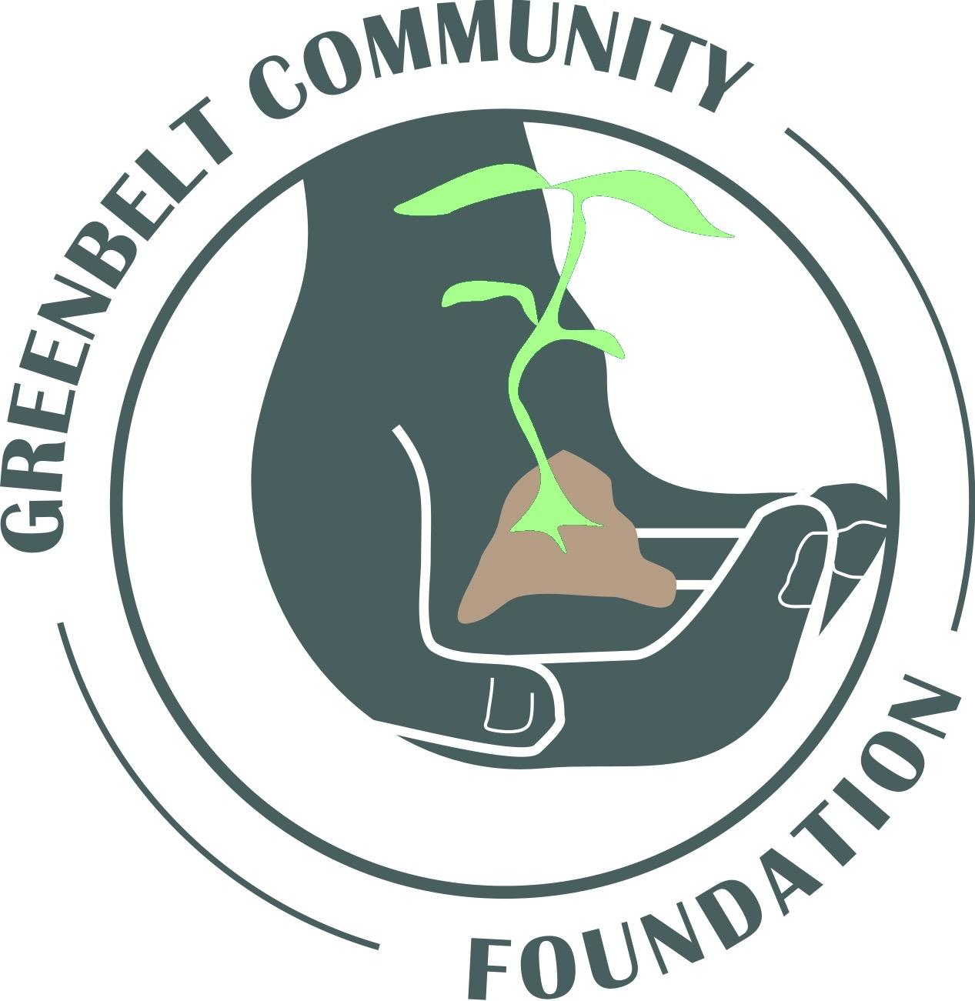
Greenbelt
COMMUNITY FOUNDATION

PROPOSAL SUBMISSION GUIDELINES
(Download as a Microsoft Word Document in order to complete the application)

The Greenbelt Community Foundation (GCF) welcomes grant applications for amounts ranging from $500 to $5,000. We are interested in funding worthwhile new or continuing projects or programs provided by nonprofit organizations and cooperatives that serve Greenbelt citizens. The project or program should enhance the vitality of Greenbelt in the following areas:
- Cultural
- Artistic
- Recreational
- Social or
- Environmental vitality of Greenbelt and

And it should:
- Benefit residents in all parts of Greenbelt
- Can be fully completed or has a clearly defined milestone that is completed by the end of the grant year.

CRITERIA
Applications will be reviewed and evaluated based on the following criteria:
- Value to Greenbelt
- Clarity of plan
- Feasibility of approach
- Qualifications of administrators and service providers
- Likelihood of success
- Potential for sustainability (if planned)

ELIGIBILITY
To be eligible for funding, your organization should be a 501(c)(3) nonprofit organization or cooperative. If you don’t meet this requirement, you must find a qualifying organization to act as your fiscal agent. A fiscal agent is an organization that is already a tax-exempt non-profit or not-for-profit cooperative that will act as a financial sponsor for your organization’s project. The fiscal agent’s mission should be in line with your organization’s mission.
A current grant recipient will need to wait 12 months from award date before it is eligible to apply for a new grant. Recipients of past grant awards must have submitted a final report to the GCF Board of Directors in order to apply for a new grant.
REVIEW PROCESS
Complete proposals will be reviewed by the Foundation’s Proposal Review Committee which sends its recommendations to the Board of Directors to make the final decisions. Award checks for the spring cycle are generally made in summer while those for the fall cycle are made in winter. Proposals are due by midnight April 15 and October 15 of each year.
SUBMISSION INSTRUCTIONS
To ensure that all your documents submitted correctly and easily reviewed, please combine all documents such as application, budget, tax-exempt letter, letters of support, etc. in one document and number each page consecutively. Please label this document “[YOUR ORGANIZATION NAME]_application for GCF.”

(Simple ways to do this: with the application in Word, you may either place all documents into the Application Word Document or print the completed application, compile it along with the other required documents in order as asked in the application, hand number each page, then scan all so they are one document.)

Please email completed proposals by midnight April 15 or October 15 to: GreenbeltCommunityFoundation@gmail.com.
Email GCF if you have questions or need assistance with your proposal.
Forms and tips:
- Proposal Writing Tips
- Grantee Report Form
- Proposal_Budget_Template
- Example of Well Written Proposal

Grant Application Form
Greenbelt Community Foundation
Application Deadlines – April and October 15

Please typed your information directly into this document. Save it as a Microsoft Word document. Combine all documents such as application, budget, tax-exempt letter, letters of support, etc. in one document and number each page consecutively. Please label this document “[YOUR ORGANIZATION NAME]_application for GCF.” Email to GreenbeltCommunityFoundation@gmail.com by midnight of April 15 or October 15.

Name of Person Completing this application: Date: Click here to enter text.
Click here to enter text.
Title: Click here to enter text.
Organization: Click here to enter text.
Street Address: Click here to enter text.
City: Click here to enter text. State: Click here to enter text. Zip: Click here to enter text.
Phone: Click here to enter text. Email: Click here to enter text.
Website: Click here to enter text. Facebook Page: Click here to enter text.
Other Social Media: Click here to enter text.
Type of Organization: If not a tax-exempt organization or cooperative, you must provide a letter from a qualifying organization willing to act as the fiscal agent for the project. The letter must include the fiscal agent organization’s mission statement and attach a copy of its current IRS determination letter
☐ 501(c)(3) Non Profit Organization. Federal tax-exempt number Click here to enter text.
☐ Not for Profit Cooperative. Federal tax-exempt number Click here to enter text.
☐ Other – complete fiscal agent information below:
Fiscal Agent Information: Federal tax-exempt number: Click here to enter text.
Organization: Click here to enter text.
Chair/President: Click here to enter text.
Street Address: Click here to enter text.
City: Click here to enter text. State: Click here to enter text. Zip: Click here to enter text.
Phone: Click here to enter text. Email: Click here to enter text.
Signature: ___________________________________________________ Date: ____________

Brief Description of the Organization: (1 paragraph):
Click here to enter text.
Title of Proposed Project: Click here to enter text.
This project/program is:
☐ New
☐ Existing

Brief Description of the Project: (1 paragraph):
Click here to enter text.
Project target area (check all that apply):
☐ Greenbelt East ☐ Greenbelt West ☐ Center Greenbelt

Amount of Funding Requested: $Click here to enter text.
_________________________________________________________________________________

REQUIRED ATTACHMENTS:
☐ Brief history of the organization with recent accomplishments
☐ Names, roles and qualifications of administrators and service providers key to the success this project.
☐ List of current board members.
☐ Organizational budget for this year including income and expense (do not include funding requested in this application).
☐ Project/Program Budget – organized by income and expense. Must include: highlighted and itemized project/program costs specifically to be funded by GCF; other sources of funding for the project/program and whether the funding is secured or pending; and inkind donations of material or services.
☐ Project Description (up to 3 pages) specifically addressing:
- Objectives of the project/program and its expected impact on Greenbelt residents.
- Who does the project/program serve - ages, gender, and location.
- Specific steps to be taken to implement the project.
- How will evaluate the project/program?
- What are your measurements for success?
- Project timeline including start date, end date, and important milestones.
- If the project is to continue for more than one year, what plans are you considering for future funding?
☐ Letter from a qualifying organization willing to act as the fiscal agent for the project. The letter must include the fiscal agent organization’s mission statement and attach a copy of its current IRS determination letter.
☐ Copy of your organization’s current IRS tax-exempt determination letter with federal tax-exempt number.
☐ Articles of Incorporation and By-laws

Proposals are evaluated based on responses to the questions above. Any additional material provided will likely not be helpful.
Proposals will be evaluated using the categories: Value to Greenbelt, Clarity of plan, Feasibility of approach, Qualifications of administrators & service providers, Likelihood of success, and Potential for sustainability (if planned). Each category is weighted equally. If your proposal is selected for an award, a final report on your project, including photos and accounting for the expenditure of the grant funds, is required at the conclusion of the project.

Revised March 2019

